Data Modelling and Management Apply stage | DAL8 SQ A3.3 |
Contents
Task 1: Conduct research on data modelling & management within your organisation 2
Task 2: Conduct research on data sources 5
Task 3: Identify reference data tables 9
Task 4: Identify data entities 11
Task 5: Create an Entity-Relationship (ER) diagram 16
Task 6: Create a basic design document 19
Task 7: Compose CREATE statements 25
Task 8: Compose SQL statements 32
Task 9: Create a basic security plan 44
Task 10: Create a basic governance plan 48
Task 11: Assess the pros and cons of a big data system and data warehousing 50

Task 1: Conduct research on data modelling & management within your organisation
You will conduct research within your organisation to explore the existing data models, tools, standards, data structures, and naming conventions in use.
The purpose of this task is to gain an understanding of the data management practices within your organisation. By conducting research, you will explore the established frameworks and guidelines that govern data modelling, tool selection, standardisation, data structures, and naming conventions.
Data models
- Investigate the data models employed within your organisation.
- Identify the types of data models used, such as relational, hierarchical, object-oriented, or dimensional models.
- Explore one or more existing data model diagrams, schemas, and documentation to comprehend the structure and relationships between entities.
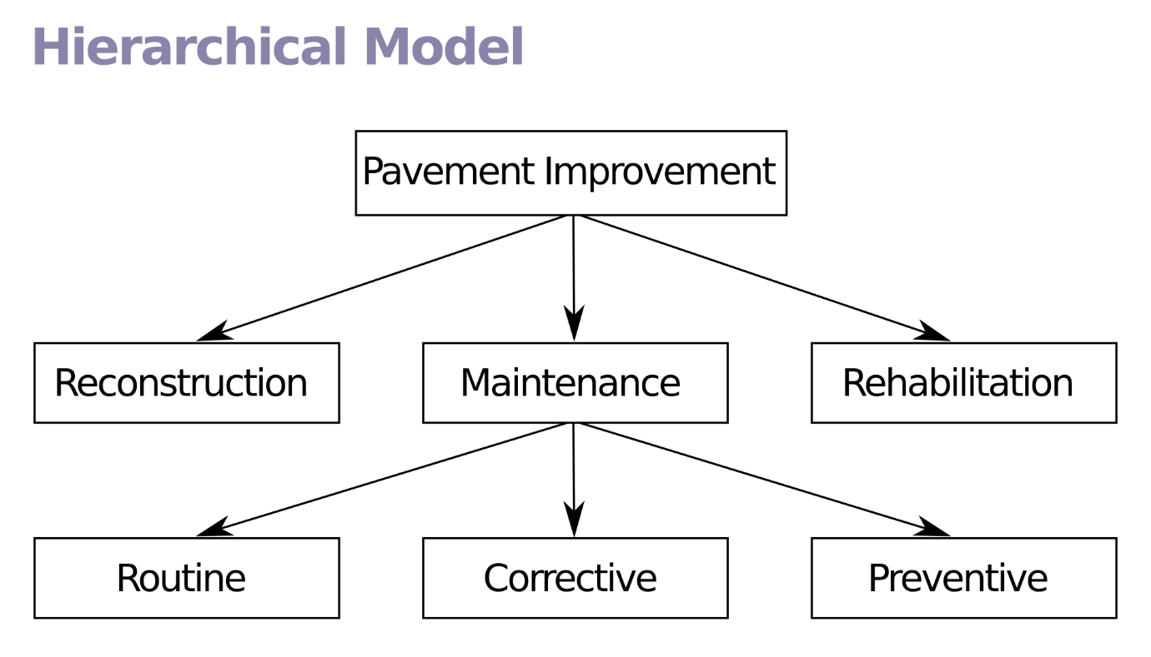
Hierarchical Model

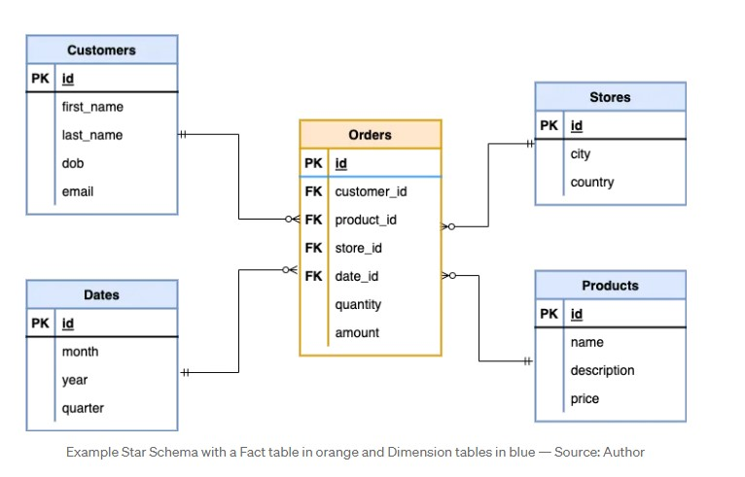

Logical Diagram

Tools and technologies
- Explore the data management tools and technologies utilised in your organisation, including database management systems (DBMS), data integration tools, data governance tools, data visualisation platforms, and any other relevant software or platforms.
- Pick one and assess its capabilities, features, and compatibility with the existing infrastructure.
Standards and best practices
- Identify the data management standards and best practices followed within your organisation. This encompasses guidelines related to data quality, data security, data privacy, data governance, and data lifecycle management.
- Take note of the established standards and protocols that ensure consistency, reliability, and compliance with regulations.
Data structures
- Examine the existing data structures employed in your organisation through one or more database or other data storage system, to understand the organisation and arrangement of data elements.
- Investigate the use of tables, columns, indexes, keys, and relationships to capture and organise the data effectively.
Naming conventions
- Analyse the naming conventions used for databases, tables, columns, and other data entities within your organisation.
- If you have time leftover, specify if there are any naming patterns and guidelines that ensure clarity, consistency, and understanding of the data elements. This includes considering conventions for abbreviations, capitalisation, special characters, and word usage.
Documentation and resources
- Review any available documentation, guidelines, or resources related to data management within your organisation. This can include data dictionaries, data modelling guides, data governance policies, and other relevant documents.
- If you have any time leftover, gather insights from these resources to deepen your understanding of the existing practices.

Task 2: Conduct research on data sources
Imagine you’ve just started as a data analyst for a movie production company. One of your responsibilities involves storing and organising information about movies produced in the last 50 years. The movie data being held should be available to the public, with all data available from reputable sources on the internet or libraries.
On your first day, you’re asked to conduct some research on potential data sources, the types of information they provide, and the necessary due diligence required for handling the data. You should consider the methods for gathering and importing the data, including batch processing and streaming.
To successfully create a security plan, follow the steps below.
Identify data sources
- Research and identify potential data sources that are relevant to the required information. These sources may include public databases, industry-specific repositories, APIs, data vendors, internal systems, or external partners.
- Evaluate the credibility, quality, and reliability of each source to ensure the data meets the required standards.
British Board of Film Classification (BBFC)
The Internet Movie Database
Wikipedia
Types of information
- Determine the types of information available from the selected data sources. This can include structured data (such as tabular data or databases) or unstructured data (such as text documents, images, or audio).
- Analyse the data formats, schemas, and any specific characteristics or complexities associated with each type.

Due diligence
- Perform due diligence on the data sources to assess their legitimacy, compliance with data privacy regulations (such as GDPR or CCPA), and adherence to ethical standards.
- Evaluate the data providers' reputation, data collection methodologies, data maintenance practices, and data usage rights to ensure legal and ethical compliance.
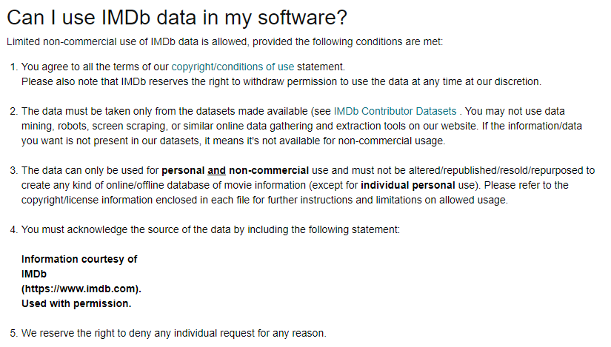
The IMDb usage rights conditions.
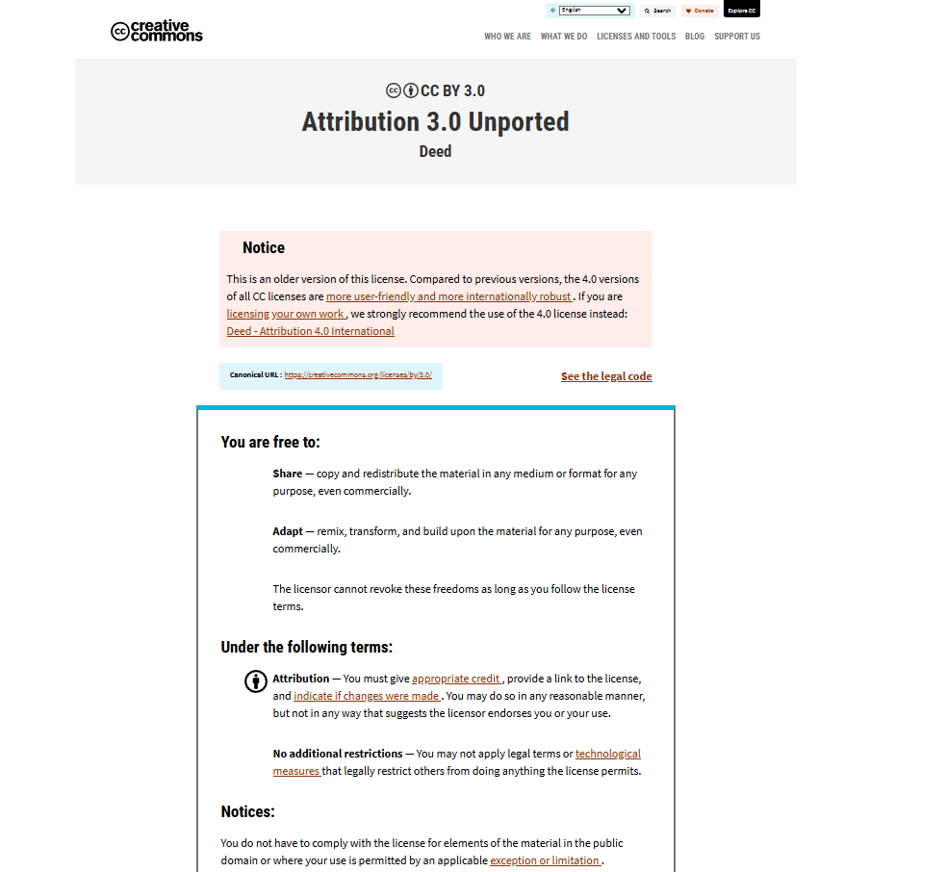
Creative Commons conditions of usage.

Data gathering methods
- Determine the most appropriate method for gathering and importing the data. Consider factors such as the volume and velocity of the data, the frequency of updates, and the desired timeliness of data availability.
Batch processing
- Assess whether batch processing is suitable for the data requirements.
Note: Batch processing involves collecting and importing data in predefined intervals or batches. It is typically suitable for scenarios where data updates occur at regular intervals or when the data can be obtained in bulk.
Streaming
- Evaluate whether streaming is a more appropriate method for data gathering.
Note: Streaming involves continuous ingestion of data in real-time or near real-time. It is ideal when data updates need to be captured immediately or when a constant flow of data is required for real-time analysis or monitoring.
Data Import Mechanisms
- Explore the available mechanisms for data import based on the selected method (batch processing or streaming). This may include utilising Extract, Transform, Load (ETL) processes, data integration tools, APIs, or custom scripts to facilitate data ingestion, transformation, and storage within the database.
Note: We do a form of ETL on the Transforming Data for Analysis course, you could use examples or screen shots from PowerBi for evidence this area.

Task 3: Identify reference data tables
You will evaluate the tables present in the Movies 2 dataset and determine if any of them can be classified as ‘reference data’, meaning they are unlikely to undergo frequent changes.
Note: Reference data refers to static information that acts as a point of reference or context for other data elements. It often includes data such as codes, classifications, standards, or lookup values that provide a consistent framework for understanding and organising other data in the dataset.
To effectively accomplish this task, follow the steps below.
Identify reference data tables
- Determine the purpose of the data, its level of volatility, and the likelihood of changes occurring.
Hint: Tables containing lists of countries, currencies, time zones, or product categories are commonly considered reference data as they tend to remain constant.
- Once you have examined each table and determined which ones qualify as reference data, make a note of these tables and their corresponding attributes.
- Additionally, provide a justification for why you believe they should be classified as reference data based on your analysis.

Reference Tables:
Languages
movie_id
language_name
language_role
Movie Production
movie_id
company_name
Country
country_iso_code
country
Genre
genre_name
genre_id
The tables above could be considered to be reference tables as the data held is most likely to be in many cases universally applied to a number of movies and is unlikely to be updated on a frequent basis.

Task 4: Identify data entities
You will evaluate the Movie 1 dataset provided and record any entities that you observe within the data presented. Additionally, you will evaluate the same data presented in a JSON format, highlighting any disparities or variations compared to the Excel format, and express your personal preference between the two.
To effectively accomplish this task, follow these steps.
Find data entities
- Carefully scrutinise the data and identify any entities that you believe are present based on the information provided.

Note: Entities may refer to specific movie titles, production companies, actors, directors, genres, or any other relevant information that can be inferred from the data.
Hint: Refer to the Entity Relationship Diagram

Entities:

JSON vs Excel
- Review the movies. json file and compare it to the original Movies 1.xlsx file.
- Make a note of any discrepancies, divergences, or deviations in the data. This includes differences in the structure, organisation, or any additional information present in the JSON format that was absent in the Excel file.

Explain the differences in structures found in both formats, for example Json files record data in ‘named pairs’ (tuples) i.e. The attribute and values sit side by side and each record is recorded in a block encapsulated in {} whereas Excel files record data in a tabular or structured table form where each record is a row. Json files are used extensively to send data in ‘packets’ for example from a web page data entry form to an online data base (some backend software creates the Json structure to wrap the data entered into the Json form which is best suited to the way internet routers work.
{
"Director": "Gore Verbinski",
"Actor": "Johnny Depp",
"gender": "Male",
"character_name": "Captain Jack Sparrow",
"gender_id": 2,
"cast_order": 0,
"movie_id": 285,
"title": "Pirates of the Caribbean: At World's End",
"budget": 300000000,
"popularity": 139.082615,
"release_date": "2007-05-19",
"revenue": 961000000,
"runtime": 169,
"vote_average": 6.9,
"vote_count": 4500,
"movie_status": "Released",
"overview": "Captain Barbossa, long believed to be dead, has come back to life and is headed to the edge of the Earth with Will Turner and Elizabeth Swann. But nothing is quite as it seems."
},
Your preferences
- Express your personal preferences regarding the data representation. Consider factors such as ease of use, readability, flexibility, and any other criteria that you find important.
- If you have time, elaborate on which format you find more suitable for data analysis and any specific reasons behind your preference.
Excel is more suited to storing data locally or on a cloud service as many systems such as PowerBi and PowerQuery are suited to the tabular (table structure) without the need to restructure it.

Task 5: Create an Entity-Relationship (ER) diagram
In this task, you will create an ER diagram using the Movies 2 dataset.
Your diagram should include a visual representation of the entities (tables) and their relationships within your database, utilising the information provided in the columns of the spreadsheet.
To effectively accomplish this task, follow the steps below.

Create the ER diagram
- Examine the columns in the spreadsheet and identify the distinct entities they represent.
Note: Entities can include tables such as movies, actors, directors, production companies, genres, release dates, and financial details like income and expenditure. Each column typically corresponds to an attribute within an entity.
- Illustrate the relationships between the different entities(tables) in your diagram.
Note: Relationships can be determined by examining columns that contain foreign keys or references to other entities. For example, a column containing movie IDs that match with the actor IDs in another column indicates a relationship between the ‘movies’ and ‘actors’ entities.
- Add appropriate symbols and notations to your diagram to represent entities, attributes, and relationships (e.g., one-to-one, one-to-many, or many-to-many).
- If you have time leftover, write a short description for each entity and its attributes. This will enhance your understanding of the data structure and facilitate subsequent analysis or database design in upcoming tasks.

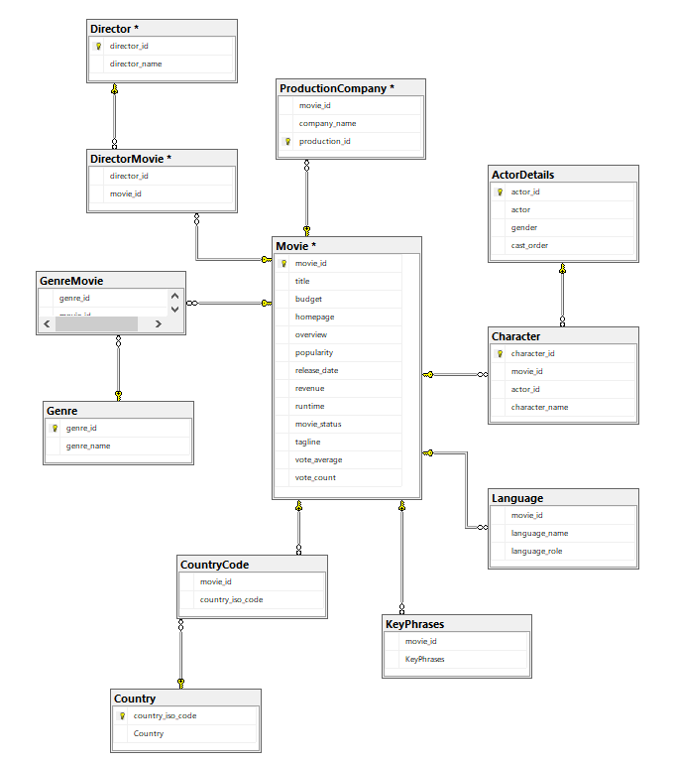
The ERD above shows how each table in the Movies database relate to others. All The relationships between the table are One – to – Many i.e. One record in the Director table can be related to Many records stored in the Movie table (a director can direct many movies).
In this diagram the Relationships are indicated by lines from one table to another, the Golden Key symbol indicates the One side of a relationship (it also indicates the Primary Key of each table if these exist) and the 8 (infinity) character, shows the Many side of a relationship.
There are also Many – to – Many relationships within the database and these have to be created as two One -to -Many relationships with a Bridging table between them.
An example can be seen between the ActorDetails table and the Movie table, one actor can star as many characters in many movies, this is a Many – to – Many relationship and needs a bridging table Character to avoid duplication of records or the need for multiple values stored in one column as this would break normalisation rules.

Task 6: Create a basic design document
You will create a basic design document that serves as a guide for your databases table design, incorporating essential metadata to enhance understanding and facilitate efficient data management.
For your basic design document, you should consider the components below.
Table names
- Provide a list of the table names that will be used in your database, ensuring they accurately represent the entities or concepts they correspond to.
Table descriptions
- Produce a brief description for each table, explaining its purpose, contents, and relationship to other tables within the database.
Columns and attributes
- Enumerate the columns within each table, along with their corresponding attributes.
- Include details such as column names, data types, lengths, constraints, and any other necessary specifications.
Note: These attributes define the nature of the data being stored, ensuring data integrity and facilitating data manipulation.
Primary keys
- Specify the primary key(s) for each table, highlighting the column(s) that uniquely identify each record within the table.
Note: The primary key is crucial for data retrieval and establishing relationships between tables.
Foreign keys
- Identify any foreign keys present in the tables, indicating the relationships between different tables.
- If you have time, specify the referenced table and column for each foreign key, helping to maintain data integrity and enforce referential constraints.
Indexes
- If applicable, outline the indexes that you would create on specific columns within the tables.
Note: Indexes enhance query performance by allowing faster data retrieval based on specific criteria.
Relationships
- Describe the relationships between tables (e.g., one-to-one, one-to-many, or many-to-many) and the corresponding columns that establish the relationship.
Metadata
- Capture additional metadata for each table, such as creation/modification dates, data source information, author details, and any other relevant information that aids in understanding the data’s origin and context.

Data Dictionary for the Movies Database (Design Document)
The Data Dictionary below details the tables, keys (foreign and primary) and how they will be related in a RDMS
For each table give a brief description of how they relate to the other tables in the database.
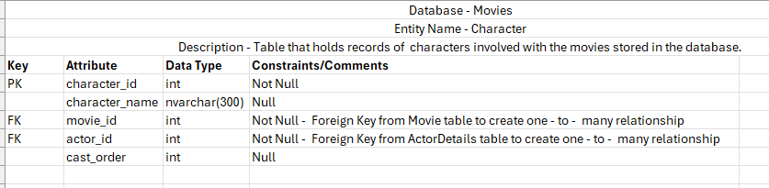
The Character table acts as a bridging table to avoid a Many - to – Many relationship between the ActorDetails and the Movie table, it has the character_id as a primary key with the foreign keys; movie_id (Movie table) and actor_id (Actor table) forming two One – to – Many relationships with it.

An index may be suitable for the Movie table as it is large and most likely to increase in size as more movies are released. Although SQL Indexes can take up more space they make for far faster querying in larger data tables.

Reference Tables
These are tables that generally contain information that many of the main tables, Movie, Actor_Details, Character and Director share. They may be considered to be reference tables as they are unlikely to be updated or change very often.
Basically all the tables that are not part of the large Movies and Actors table can be considered reference tables.
Example:
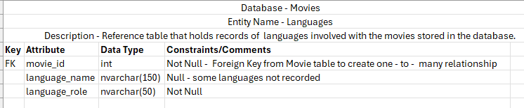

Task 7: Compose CREATE statements
You will compose the necessary CREATE statements for the tables in your database.
The purpose of this task is for you create the necessary tables in your database in a manner that facilitates the storage and organisation of data in a structured manner.
To effectively accomplish this task, follow the steps below.
Table name and columns
- Specify the name of each table and list the columns it will contain. You should consider the purpose and nature of the data being stored when naming the tables.
- Specify the name of each column, along with its data type, length (if applicable), and any constraints required.
Primary key
- Identify the primary key for each table.
- Designate the column(s) that uniquely identify each record within the table to enforce data integrity.
Foreign key (if applicable)
- Identify if there are any relationships between tables.
- If there are, include the necessary foreign keys in your CREATE statements.
- If you have time, specific the referenced table and column for each foreign key to establish the relationships accurately.
Constraints (if applicable)
- Identify any additional constraints that need to be applied to the tables.
Note: This may include NOT NULL constraints, unique constraints, or check constraints to enforce specific data rules or business logic.

Briefly explain what each of the queries does.
Example:
Create Database Movies_50
use database Movies_50

CREATE TABLE Director

(
director_id int PRIMARY KEY,
director_name nvarchar(50) NOT NULL
)
Example:
This create statement is part of the category DDL (Data Definition Language) in this example an empty table is created to hold information about the film directors recorded in the data base Movies.

Indexes (if applicable)
- Do any indexes need to be created for the tables to enhance query performance?
- If you have time, include the relevant index creation statements based upon the columns that will be frequently used in search criteria or join operations.
Example:
Unclustered index on Movie table.

CREATE INDEX idx_MovieTitle
ON Movie (title);
An index may be suitable for the Movie table as it is large and most likely to increase in size as more movies are released. Although SQL Indexes can take up more space they make for far faster querying in larger data tables.
Table options (if applicable)
- Are there any table-specific options that need to be set? For example, storage parameters, compression settings, or table-level security configurations.

Review your CREATE statements (optional)
- Do your CREATE statements adhere to the specific SQL dialect or database management system you are using?
- Pay attention to syntax, quotes, and any other requirements for your chosen database.

Task 8: Compose SQL statements
You will compose example SQL statements for SELECT, INSERT, UPDATE, and DELETE operations on the tables in your database.
The purpose of this task is for you to demonstrate your ability to retrieve, insert, modify, and delete data within a database.
To effectively accomplish this task, follow the steps below.
DML (Data Manipulation Language)
SELECT statement
- Write some SELECT statements to retrieve data from tables in your database.
- Your statements should specify the desired columns to be returned and the table(s) from which to retrieve the data.
- If you have time, demonstrate your ability to use conditions, joins, and aggregate functions where necessary to filter and manipulate the data.
Note: we will run these and take screenshots during the course.

Select Statements
Briefly explain what each of the queries does.
Example:
Select List
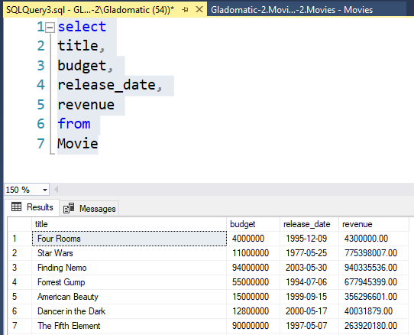
Example:
This select statement is part of the category DML (Data Manipulatiion Language) in this example a list of attributes from the Movie table is displayed.

Inner Join
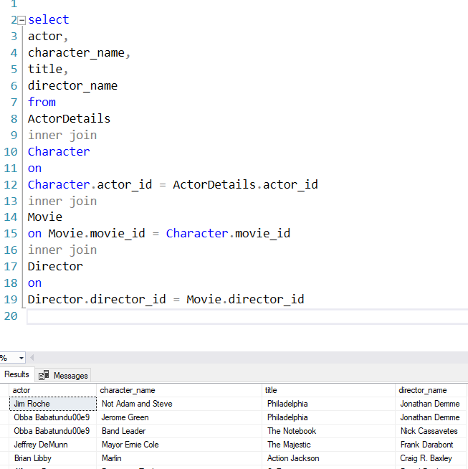

INSERT statement
- Write some INSERT statements to add new records to the tables in your database.
- Your statements should specify the table name and the values to be inserted into the respective columns.
- If necessary, include a column list to ensure values are inserted into the correct columns.
Example:
DDL (Data Definition Language)
INSERT INTO Director (director_id, director_name)
VALUES
('1576','John','Carpenter'),
('1577','Sofia','Coppola'),
('1578','John','Waters')
Example:
UPDATE Statement
The UPDATE clause is used to update records to in tables
UPDATE Movie
SET Release_Date = '01/01/1999',
movie_status = 'Released'
WHERE movie_id='5'

Example:

DELETE statement
- Write some example DELETE statements to remove records from tables in your database.
- Your statements should specify the table name and apply conditions to identify the specific records to be deleted.

Example:
DELETE FROM Movie
WHERE movie_id='125'
Although most tables in a RDMS have a built in or clustered index, an unclustered index can be added also.
An unclustered index is similar to having a table of contents or index in a book and can speed up SQL queries greatly as the SQL engine does not have to look through every row to find its results, it can use the index to find which rows it needs.
INDEX
CREATE INDEX idx_MovieTitle
ON Movie (title);
Stretch and challenge (optional)
- In each of your statements, include comments or explanations to clarify their purpose and usage.
- Highlight any considerations or restrictions, such as data validation, transactional integrity, or any business rules that need to be adhered to.

Review your SQL statements (optional)
- Do your statements adhere to the specific SQL dialect or database management system you are using?
- Pay attention to syntax, quotes, and any other requirements for your chosen database.

Task 9: Create a basic security plan
You will create a basic security plan for your database, outlining access privileges and permissions for editing and querying the tables.
The purpose of this task is for you to consider the appropriate security measures that are needed to protect data.
For your basic security plan, you should consider the areas below.
Take some screenshots from SQL Server to evidence Security Roles etc.
Identify user roles
- List as many roles or user groups that will interact with your database as you can think of. Examples may include administrators, data analysts, developers, and end users.
- If you have time, categorise these roles based on their specific responsibilities and access requirements.
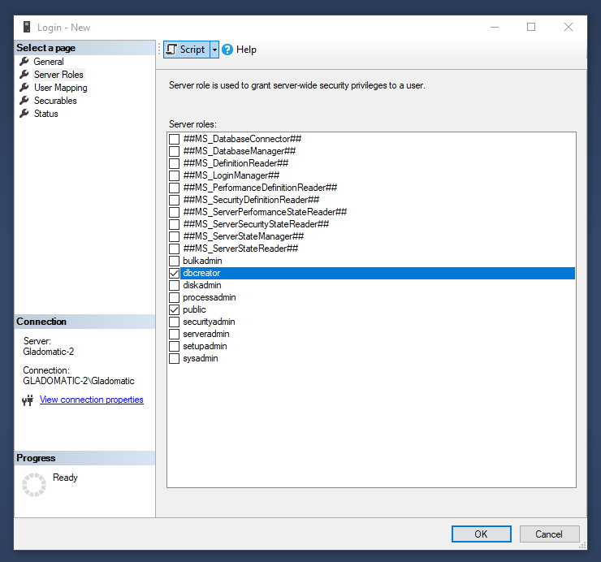
People who use the database can be granted a variety of roles by a systems administrator. Refer to the document Security.docx and list some of the roles and who might use them i.e. someone just visiting an online database would login but only have Read Only rights to some of the tables.

Define access levels
- Assign different access levels to a few roles based on their needs and responsibilities. For example, granting privileges such as read-only access.
- For the roles you’ve selected, define the specific permissions and restrictions associated with each access level.
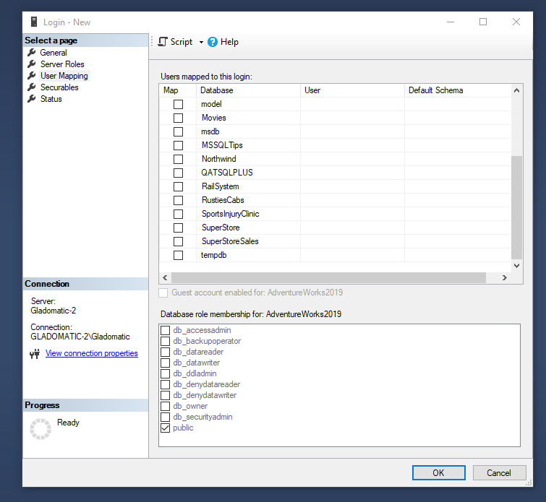
Once a user has been given a login and username by the system admin, the sys admin can allocated which databases and even tables the can access or whether they can change data on any of the records. For example a user who is allowed to update the Movie table if any movies get added will be given the permissions to do this. Think of 3 other roles that a movie database might require, this could be related to other departments, finance, sales, customer accounts etc.

User authentication:
- Highlight the user authentication mechanism you’ll use to verify the identity of individuals accessing the database. For example, username/password authentication, multi-factor authentication, or integration with an existing authentication system (e.g., Active Directory).

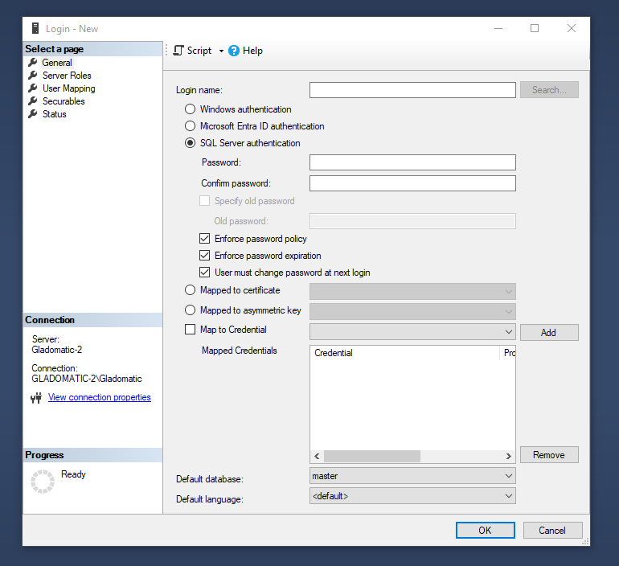
If SQL Server is set to SQL Server Authentication then the sys admin can create unique login details (username/password) for everyone likely to need access to the database records. Some users will need more access than others and some data will be accessible only to those with data controller type authority.
Authorisation and permissions:
- Define the authorisation rules and permissions for a few of the user roles. For instance, the tables, columns, and operations (edit or query) that each role is allowed to perform.
Note: It is best practice to limit access to sensitive data or critical database components to only authorised personnel.

Data encryption
- Explain what data encryption techniques you would implement to protect sensitive data at rest and in transit.
You may need to research a little about encryption methods.
Audit trails and logging
- Explain what recording and monitoring mechanisms you would use to detect and investigate any unauthorised or suspicious activities.
An example might be to create an audit table that runs in the background of the database and simply extracts collects the username and system datetime from anyone updating or adding records to any of the tables within the database. SQL triggers can be placed on existing tables in the database to add a record like this every time a change is made to a table.
Regular user access reviews (optional)
- Explain how you would structure reviews to ensure user access privileges are appropriate and aligned with the users’ roles and responsibilities.
Training and awareness (optional)
- Explain how you would educate users about database security practices, data handling policies, and the importance of maintaining data confidentiality and integrity.
- What else would you do to promote a culture of security consciousness throughout your organisation?

Task 10: Create a basic governance plan
You will create a basic governance plan for your database, including mechanisms to ensure data accuracy, and enabling users the right to edit or remove their personal data when required.
You can include some screenshots of the Backup and Restore wizards from SQL Server
For your basic governance plan, you should consider the areas below.
Data quality assurance
- Explain what procedures you would use to address data discrepancies or errors promptly to ensure the data in your database remains accurate, consistent and up to date.
Data update mechanism
- Document a process and/or schedule for data updates.
- Mechanisms to consider include, integrating data from reliable sources, establishing data integration processes, or implementing data feeds to auto update the database with the latest information.
Right to edit
- Document a process, that enables users to exercise their right to edit their personal data within a database. This may involve providing a user-friendly interface or self-service portal where users can securely update their information.
- If you have time, specify the authentication and authorisation mechanisms you would use to ensure the validity of data edits.

Data removal mechanism
- Document the procedure for the prompt and secure deletion of personal data and how you will maintain audit trails of such actions.
Privacy and consent management
- Document simple processes to a) capture and maintain user consent for data collection and processing and b) handle consent revocation requests effectively.
Data retention policies (optional)
- Document a simple process to automatically archive or delete data based on a retention period you want to define.
Note: In the workplace, you will need to consider legal and regulatory requirements, business needs, and data usage purposes when establishing these policies.
Documentation and communication (optional)
- Explain how you would communicate the plan to stakeholders, users, and relevant teams within the organisation to ensure understanding and adherence to the governance requirements.
Regular review and compliance monitoring (optional)
- Explain how you would periodically review the governance plan so that it remains aligned with evolving regulations, industry best practices, and organisational needs.

Task 11: Assess the pros and cons of a big data system and data warehousing
You will now evaluate your dataset and choose suitable big data systems or data warehousing architectures.
The purpose of this task is for you determine the potential advantages and drawbacks of implementing such systems for managing and analysing your dataset.
To effectively accomplish this task, follow the steps below.
Dataset characteristics
- Evaluate the characteristics of your dataset in terms of its volume, velocity, variety, and veracity – the four Vs of big data.
- Assess your dataset's size and growth potential, the speed at which data is generated, the diversity of data types, and the quality and reliability of the data.
- This analysis, plus the questions below, will help you determine whether your dataset aligns with the criteria that typically warrants a big data system.
Scalability requirements
- Would your dataset grow significantly over time or can you foresee any periodic spikes in data volume?
- If yes, would a traditional data management system be able to handle the potential scale or would big data system be more suitable for accommodating future growth?
Complex data processing
- Evaluate whether your dataset requires advanced processing capabilities, such as complex analytics, machine learning, or natural language processing.
- Does the dataset's complexity necessitate distributed computing, parallel processing, or advanced algorithms that would be better supported by a big data system?

Real-time data processing
- Is real-time or near real-time data processing is essential for your dataset?
- Would you be able to provide any insights or rapid decisions without analysing streaming or event-driven data?
- How important it is for a big data system to handle high-velocity data ingestions and real-time processing?
Data integration and centralisation
- How reliant do you need to be on integrating and centralising data from diverse sources?
- Does your dataset require bringing together structured and unstructured data from various systems, applications, or external sources?
- Is a data warehousing solution suitable for consolidating and providing a unified view of your data?
Data governance and compliance
- Does your dataset contain sensitive information that necessitates strict access controls, encryption, or compliance with data protection regulations?
- Would a data warehousing solution provide the necessary features and controls to meet these requirements?
Cost and resource considerations
- What are the financial and resource implications associated with implementing a big data system or data warehousing? Consider factors such as infrastructure costs, data management expertise, and ongoing maintenance requirements.
- Do the potential benefits outweigh the associated expenses?
Analytics and insights
- Imagine if your dataset required advanced analytics, data mining, or predictive modelling, what would be better to support this, a big data system or warehousing solution?

